The race officer set-up and race start sequence manager, looks like this:
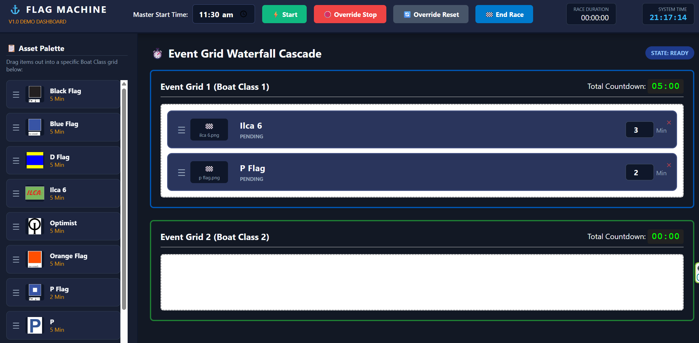
There is a large display board facing the siling course:
The display board has 4 panels, we will treat this as a display grid linked to the event grid
The sailors will see the active sequence from the Event grid – show only the flag and the Total countdown , Flag in cell 1 and countdown in cell 2: The total Count down must be minutes only: this si standard flag convention for sailing
E.g


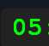

Make this on a separate html page http://127.0.0.1:5000/dispaly

